Anywhere USB Permitted Device List

The Anywhere USB product has an option that will limit access to a set of select devices. This option allows an administrator to add specific Vendor ID/Product ID or Class values into the registry. Anywhere USB will compare the IDs of each USB device, when it is connected, with the value in the registry and if there is a match the device will enumerate, otherwise an “Unknown Device” message will appear in the status bar.
The key is located in the following location in the registry:
HKEY_LOCAL_MACHINE\SYSTEM\CurrentControlSet\Services\ionhub
The new key value is “PermittedDevices.” This Multi String value contains a list of devices that the AnywhereUsb will enumerate all other devices will show as “Unknown Device.”
The following are some examples of values in the permitted device list
- For a hub use the value “GENERICHUB” (Class_09 is not supported)
- For a composite device use the value “COMPOSITE”
- For specific device use Vid_xxxx&Pid_yyyy where xxxx and yyyy are the vendor id and product id of the device
- For a device class such as mass storage use Class_xx where xx is the class of device
COMMUNICATIONS 02
HUMAN INTERFACE 03
PRINTER 07
STORAGE 08
VENDOR SPECIFIC FF

Examples:
To allow a specific usb device with an embedded hub:
PermittedDevices REG_MULTI_SZ Vid_1608&Pid_0215 GENERICHUB
To allow all Human interface devices such as mouse or keyboard:
PermittedDevices REG_MULTI_SZ Class_03
To allow all mice and all printers
PermittedDevices REG_MULTI_SZ Class_03 Class_07

The Vid/Pid values can be found using the AnywhereUSB viewer utility. The field are called idVendor and idProduct.

The following is a view of the registry with the new key:
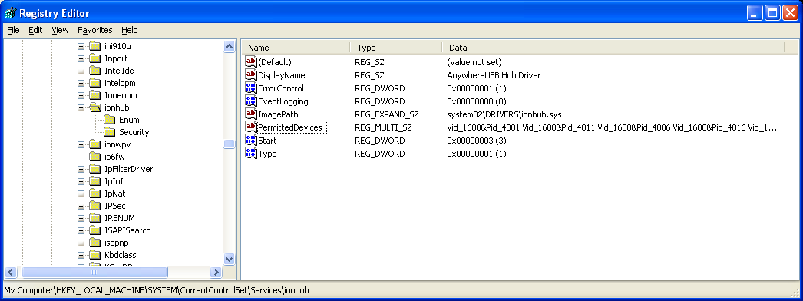

Double clicking on the key will bring up the Edit Multi-String dialog.
